**Music Store Data Analysis Project using PostGreSQL**

Tool : PostGreSql

--Senior employee based on level

Select * from employee

Order by levels DESC

LIMIT 1;

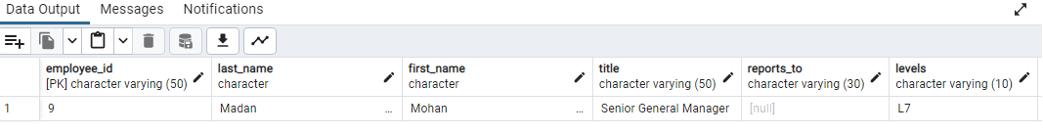

--which countries have the most invoices?

Select billing_country, count(*) as C from invoice

Group by bIlling_country

order by C DESC;

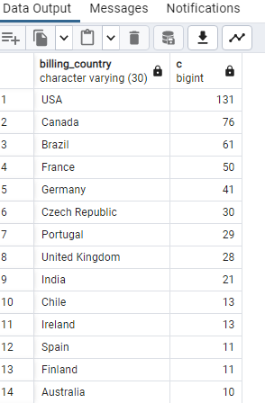

--City with best customers and hightest invoices Total.

Select billing_city, sum(total) as s from invoice

group by billing_city

order by s DESC

LIMIT 1;

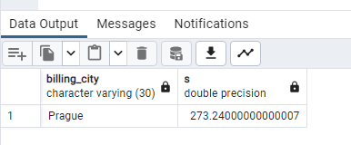

--Best customer who spent the most money

select C.customer_id, C.first_name ,C.last_name, sum(I.total) as Total_Payment

from customer C

JOIN invoice I

ON C.customer_id = I.customer_id

Group by C.customer_id

order by Total_Payment DESC

LIMIT 1;

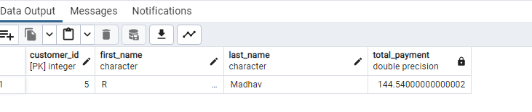

-- Write query to return the email, first name, last name, & Genre of all

Rock Music listeners.

Return your list ordered alphabetically by email starting with A.

Select * from customer;

Select * from genre;

Select * from invoice_line;

select * from track;

Select * from invoice;

Select DISTINCT email, first_name, last_name from customer C

JOIN invoice I ON C.customer_id = I.customer_id

JOIN invoice_line ON invoice_line.invoice_id = I.invoice_id

Where track_id IN (select track_id from track

Join genre on track.genre_id = genre.genre_id

where genre.name like 'Rock'

)

order by email;

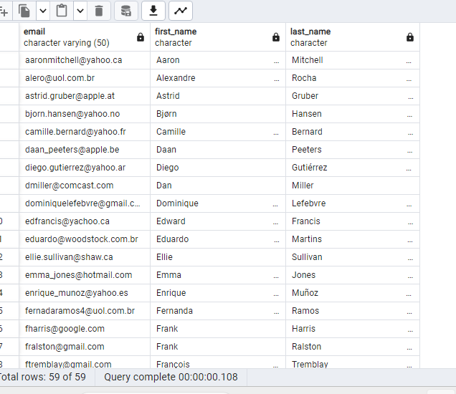

-- Let's invite the artists who have written the most rock music in our dataset.

Write a query that returns the Artist name and total track count of the

top 10 rock bands.

Select * from artist;

select * from track;

select * from genre;

Select * from album;

Select * from customer;

Select artist.artist_id, artist.name, count(artist.artist_id) from track

JOIN Album ON track.Album_id = Album.Album_id

JOIN genre ON genre.genre_id = track.genre_id

JOIN Artist on Artist.Artist_id = Album.Artist_id

Where genre.name LIKE 'Rock'

Group by artist.artist_id

ORDER BY count(artist.artist_id) DESC

LIMIT 10;

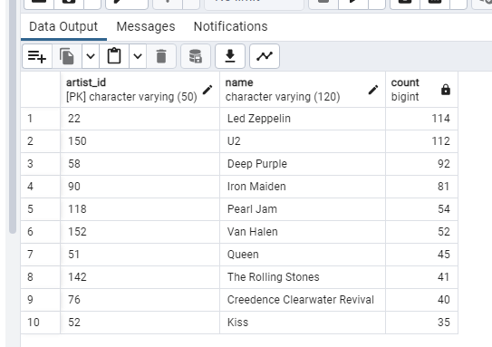

--Return all the track names that have a song length longer than the

average song length. Return the Name and Milliseconds for each track.

Order by the song length with the longest songs listed first.

Select track.name, milliseconds from track

where milliseconds > (Select avg(milliseconds) from track)

Order by Milliseconds DESC

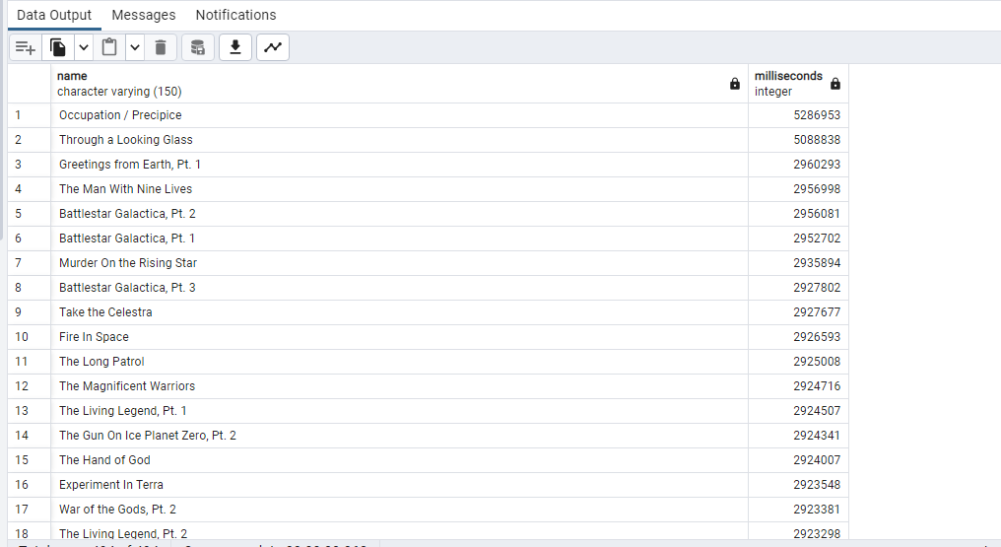

--Find how much amount spent by each customer on artists?

--Write a query to return customer name, artist name and total spent

With best_Selling As (

Select artist.artist_id, artist.name as artist_name,

sum(invoice_line.unit_Price * invoice_line.quantity) as total_Sales

from invoice_line

JOIN track on track.track_id = invoice_line.track_id

JOIN album on album.album_id = track.album_id

JOIN artist on artist.artist_id = album.artist_id

Group by 1

Order by 3 DESC

LIMIT 1

)

Select c.customer_id, c.first_name, c.last_name, bs.artist_name,

sum(il.unit_price * il.quantity) as sales

from invoice i

JOIN customer c on c.customer_id = i.customer_id

JOIN invoice_line il on il.invoice_id = i.invoice_id

JOIN track t on t.track_id = il.track_id

JOIN album alb on alb.album_id = t.album_id

JOIN best_selling bs on bs.artist_id = alb.artist_id

Group by 1,2,3,4

Order by 5 DESC

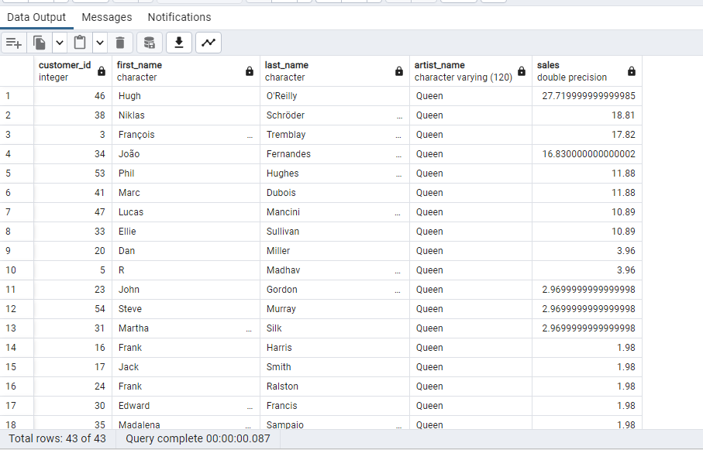

--We want to find out the most popular music Genre for each country. We determine the most popular genre as the genre with the highest amount of purchases.

--Write a query that returns each country along with the top Genre. For countries where the maximum number of purchases is shared return all Genres.

With most_popular_genre AS (

select count(invoice_line.quantity) as purchase, customer.country, genre.name,

genre.genre_id, ROW_NUMBER() OVER(Partition by customer.country

order by count(invoice_line.quantity) DESC) as Rowno

from invoice_line

JOIN invoice on invoice.invoice_id = invoice_line.invoice_id

JOIN customer on customer.customer_id = invoice.customer_id

JOIN track on track.track_id = invoice_line.track_id

JOIN genre on genre.genre_id = track.genre_id

Group by 2,3,4

Order by 2 ASC, 1 DESC

)

select * from most_popular_genre where Rowno <=1

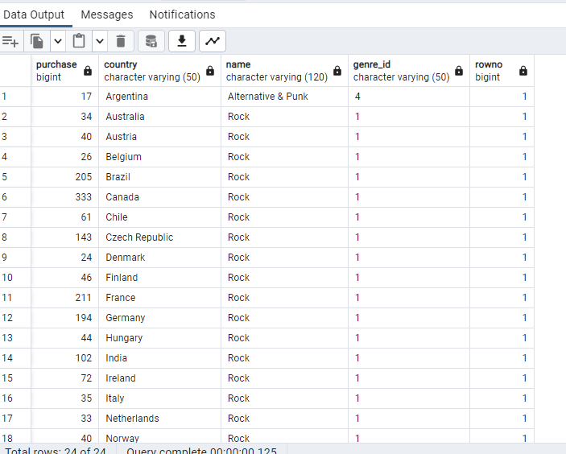

/*Write a query that determines the customer that has spent the most on music

for each country.Write a query that returns the country along with the top

customer and how much they spent.For countries where the top amount spent is

shared, provide all customers who spent this amount. */

with customer_by_country as (

select customer.customer_id, customer.first_name, customer.last_name, billing_country,

sum(total) as total_spent, Row_number()

over(Partition by billing_country order by sum(total) DESC) as Rowno

from invoice

JOIN customer on customer.customer_id = invoice.customer_id

Group by 1,2,3,4

Order by 4 ASC, 5 DESC

)

Select * from customer_by_country where rowno<=1

